Thermal overstress aging with DC gate voltage bias
The Matlab file “20080429T135531.mat” contains data from a thermal overstress aging experiments using a DC bias in the gate voltage. The experiment controls the package temperature within a range outside the rated temperature （额定温度）of the device with the objective of accelerating the aging of the device. Several parameters were monitored like collector current, collector voltage, gate voltage and package temperature.
The configuration of the device consists on connecting the emitter to the ground of the power supply and the collector with a resistor in series （串联）to the positive lead of the power supply. The gate was driven by an independent power supply which ground was also connected to the emitter.
The data collection on this experiment was done with standard data acquisition equipment from National Instruments and referred to in our IEEE Autotestcon paper (attached here) as steady-state measurement. What this mean is that the measurements were slow and some of the detail of the transients response after switching is lost. From this data though, it can be observed that the shape of the collector current after switch-OFF changes as the device ages. This current tail is considered as a leading indicator of failure (failure precursor) for the development of prognostics algorithms.
通过瞬态和稳态方法，可以引起电应力过大。瞬态方法包括静电放电（ESD）、感应开关和电磁脉冲。静电放电是导致栅极氧化物失效[13]和电感负载硬开关的主要原因，会导致电压尖峰，从而对漏源结造成严重损坏[14]。我们可以区分热致失效机制（接触金属烧损、熔融金属化）和电场引起的损伤。稳态方法包括长期过电压和过电流。应用高栅极电压[6]、设置栅极电压（Vg）以使漏极电流最大化[7]，以及在漏极[15]上施加电流过应力已被证明可诱导热载流子和TBBD[10]。可以监测的故障前兆包括集电极-发射极泄漏、栅极泄漏、GM变化和VGTH偏移。
两个测试对象已经在LabVIEW开发环境中进行了彻底的开发，其他测试对象正在进行改进。第一个测试对象执行一个热退化场景，将晶体管自加热到指定温度，并通过栅极开关将其保持在温度边界内。采集并记录所有瞬态、热态和稳态信号。如果发生故障，实验很快就结束了，以保护晶体管。第二个测试对象对晶体管封装进行热阻抗表征。晶体管以已知的功率设置自加热到恒定的温度。然后关闭晶体管，测量其温度衰减并提取热阻抗偏移。额外的老化软件在精化下执行热循环，注入热载体，并导致电应力过大。改进下的附加特性软件测量栅极阻抗，执行脉冲IV曲线测量和提取开关特性

Experiments settings
- Gate Voltage (Vg): 10V DC
- Low Temperature Threshold: 268ºC
- High Temperature Threshold: 270ºC
- Max Temperature: 305ºC (Thermal runaway setting)

Experiments comments
- Experiment lasted approx. 4 hrs.
- Experiments stopped after latch-up and thermal runaway
- Brought up package temperature incrementally (220ºC, 240ºC, 270ºC)（逐渐地）
- Device part number: IRF-G4BC30KD

Representative plots

Temperature:
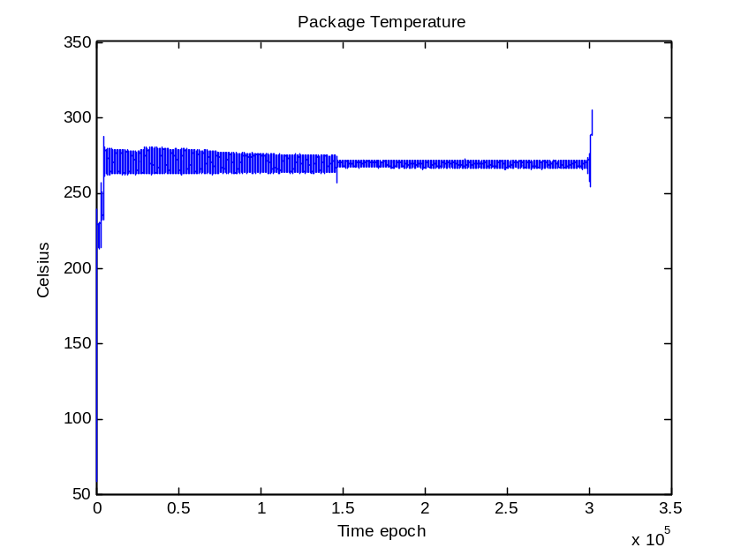
Figure 1: Package temperature measurement throughout aging time period.

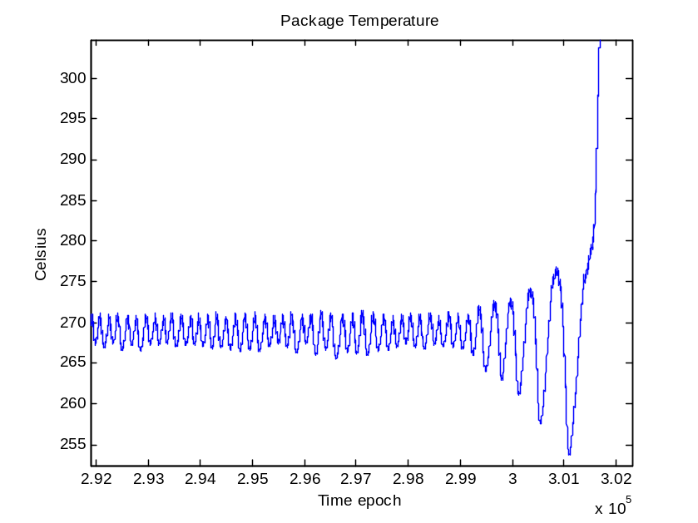
Figure 2: Package temperature measurements at the end of aging (thermal runaway).

Collector-Emitter Current:
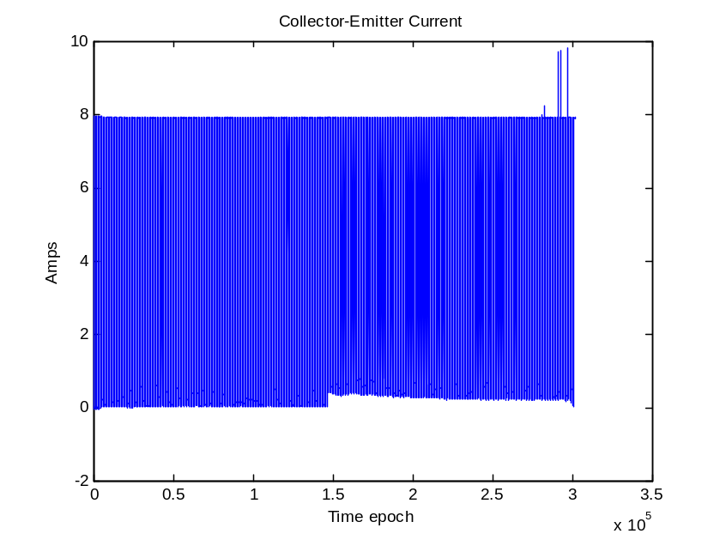
Figure 3: Collector current measurement throughout aging time period.
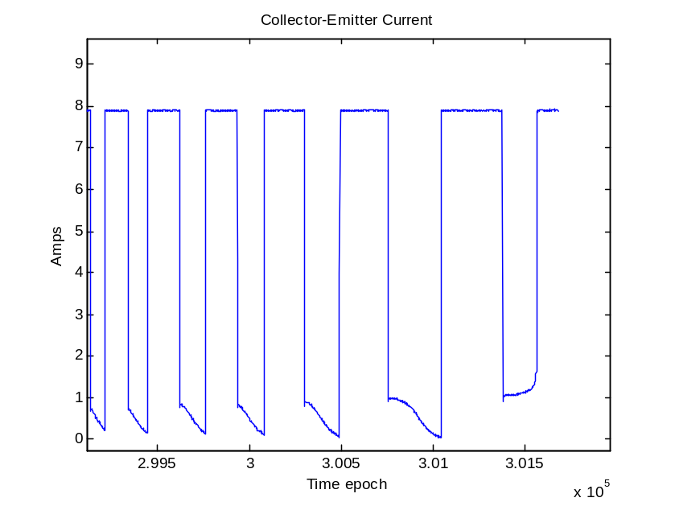
Figure 4: Collector current measurements at the end of aging (thermal runaway).

